Fundraising Boot Camp | Deal & Product Valuations
Launching and Executing  a Fundraising Campaign | Learn what the key parameters are  and how to structure a licensing deal

WHEN: 25 February 2020 09:00 - 12:00
WHERE: Bio-Technopark. Wagistrasse 25, Schlieren-Zurich
In preparation for the second Redefining Early Stage Investments (RESI) conference to be held in Europe, Life Science Nation and Venture Valuation are offering Tech Hubs around Europe a Bootcamp addressing key topics for early-stage life science companies.

9:00-10:30 Fundraising Workshop Overview
Presenters: Dennis Ford, Founder and CEO, LSN; Creator of the RESI Conference Series; Greg Mannix, Vice President International Business Development, LSN  Workshop Overview:  - About Life Science Nation (LSN) and RESI  - Raising Capital: The 3 Most Important Questions  - The Changing Investor Landscape  - Debunking the Top 10 Old Myths in Fundraising  - Planning & Infrastructure for an Outbound Fundraising Campaign  - Building Your Brand Through Consistent Messaging  - Key Components of Fundraising Marketing Collateral | 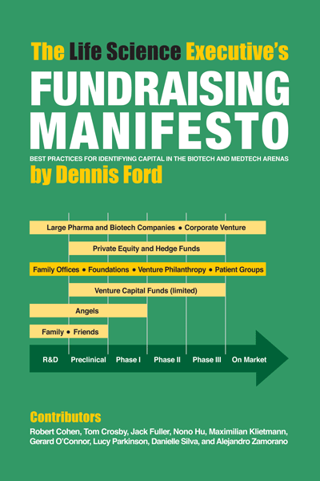  Click Here to Download  Free Digital Copy
10:30-11:00 Coffee Break
11:00-12:00 Valuation Workshop Overview
Presenter: Patrik Frei, Founder & CEO, Venture Valuation

Workshop Overview:
- Calculate potential of a company or product and associated risks
- Calculate and determine the right assumptions to structure a licensing deal
- Key parameters of a licensing deal
- Metrics of licensing deals
12:00-14:00 One-on-one Office Hours - companies that wish to have a 30-minute meeting with Dennis and Greg to discuss fundraising can book a time by contacting Joey Wong by email j.wong@lifesciencenation.com
Supported by: FREE REGISTRATION
http://events.constantcontact.com/register/event?llr=xe68typab&oeidk=a07egvgn4n57cdb1f3f

